

CLIENT: | Thelen Kia | PHONE #:
SPOT: | THEL-KI-T210101 Jan Thelen Kia | FAX # :
LENGTH: | :30 | SALES REP: | Larry H.
DATE: | 1/8/2021 | PRODUCER | A. Dennis

GRAPHICS | Video | AUDIO
Thelen Kia Logo  Euclid Ave. - Bay City  www.ThelenKia.com  2021 Kia Forte GT-Line  Purchase From Just $239/mo  3.9% APR for 84 Months  VIN #: 3KPF34AD6LE261817. MSRP $21,455. Stock# K9390. Taxes, title & license fees extra. 3.9% APR for 84 months equals 13.62 per $1,000 financed through WAC, with approved credit, for well qualified buyers. Not all customers will qualify. No security deposit required. See Thelen Kia for details. Ends January 31, 2021.  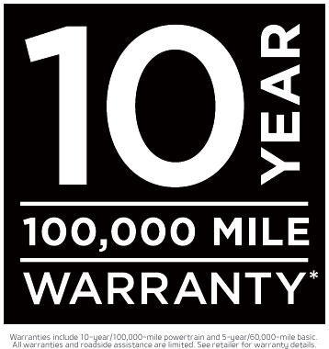  Warranties include 10-year/100,000-mile powertrain and 5-year/60,000-mile basic. All warranties and roadside assistance are limited. See retailer for warranty details.  2021 Kia Sportage LX FWD  Lease From Just $239/mo  For 36 Months $733 Due At Signing  VIN #: KNDPM3AC1M7857535. Model Code 42222. Lease 10,000 miles per year for well qualified buyers with approved credit. Taxes extra. No security deposit required. See Thelen Kia for details. Ends January 31, 2021.  Think Thelen (Logo)  Kia (logo)  Euclid Ave. - Bay City www.ThelenKia.com | GFX: Kia Logo  GFX: 2021 Kia Forte GT photo  GFX: Various 2021 Kia Models  GFX: 2021 Kia Sportage photo  GFX: Logo Animation  Video: Thelen Kia Dealership drone footage | Announcer: (:)  Save MORE at Thelen Kia in Bay City!  This month, the number to remember is 239!  Because right now at Thelen Kia, you can buy a new Kia Forte GT for just $239 a month! With $0 Down!  Plus get Kia’s 10-year/100,000-mile limited warranty!  Or lease a new Kia Sportage LX for, you guessed it, $239 a month! With $0 Down!  Think Thelen Kia - and get more for your money! Euclid avenue in Bay City! Online at thelenkia.com  Thelen Kia - It’s the Right Thing to Do!

